**Vivekanand Education Society’s**

**Institute of Technology**

**(Affiliated to University of Mumbai, Approved by AICTE & Recognized by Govt. of Maharashtra)**

**Department of Information Technology**

AIDS - 2 Lab

Experiment - 11

Aim: Analysis and comparison (ML and DL)

| Roll No. | 53 |
| --- | --- |
| Name | SAKSHI SANTOSH PATIL |
| Class | D20B |
| Subject | AIDS - 2 |
| Grade: |  |

**EXPERIMENT 11**

**AIM:** Analysis and comparison (ML and DL)

**THEORY**:

**MACHINE LEARNING**

Machine Learning is a branch of artificial intelligence that develops algorithms by learning the hidden patterns of the datasets used it to make predictions on new similar type data, without being explicitly programmed for each task.

Traditional Machine Learning combines data with statistical tools to predict an output that can be used to make actionable insights.

Machine learning is used in many different applications, from image and speech recognition to natural language processing, recommendation systems, fraud detection, portfolio optimization, automated task, and so on. Machine learning models are also used to power autonomous vehicles, drones, and robots, making them more intelligent and adaptable to changing environments.

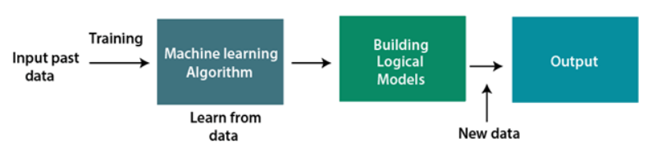

Classification of Machine Learning:

Machine learning can be classified into three types:

1. **Supervised learning**

In supervised learning, sample labeled data are provided to the machine learning system for training, and the system then predicts the output based on the training data.

The system uses labeled data to build a model that understands the datasets and learns about each one. After the training and processing are done, we test the model with sample data to see if it can accurately predict the output.

The mapping of the input data to the output data is the objective of supervised learning. The managed learning depends on oversight, and it is equivalent to when an understudy learns things in the management of the educator. Spam filtering is an example of supervised learning.

Supervised learning can be grouped further in two categories of algorithms:

1. Classification
2. Regression
3. **Unsupervised learning**

Unsupervised learning is a learning method in which a machine learns without any supervision.

The training is provided to the machine with the set of data that has not been labeled, classified, or categorized, and the algorithm needs to act on that data without any supervision. The goal of unsupervised learning is to restructure the input data into new features or a group of objects with similar patterns.

In unsupervised learning, we don't have a predetermined result. The machine tries to find useful insights from the huge amount of data. It can be further classifieds into two categories of algorithms:

1. Clustering
2. Association
3. **Reinforcement learning**

Reinforcement learning is a feedback-based learning method, in which a learning agent gets a reward for each right action and gets a penalty for each wrong action. The agent learns automatically with these feedbacks and improves its performance. In reinforcement learning, the agent interacts with the environment and explores it. The goal of an agent is to get the most reward points, and hence, it improves its performance.

The robotic dog, which automatically learns the movement of his arms, is an example of Reinforcement learning.

**Linear Regression in Machine Learning**

Linear regression algorithm shows a linear relationship between a dependent (y) and one or more independent (y) variables, hence called as linear regression. Since linear regression shows the linear relationship, which means it finds how the value of the dependent variable is changing according to the value of the independent variable.

The linear regression model provides a sloped straight line representing the relationship between the variables.

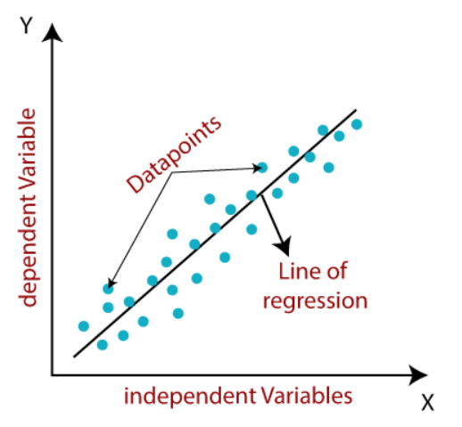

Mathematically, we can represent a linear regression as:

y= a0+a1x+ ε

The values for x and y variables are training datasets for Linear Regression model representation.

Here,

Y= Dependent Variable (Target Variable)

X= Independent Variable (predictor Variable)

a0= intercept of the line (Gives an additional degree of freedom)

a1 = Linear regression coefficient (scale factor to each input value).

ε = random error

**Logistic Regression in Machine Learning**

Logistic regression predicts the output of a categorical dependent variable. Therefore the outcome must be a categorical or discrete value. It can be either Yes or No, 0 or 1, true or False, etc. but instead of giving the exact value as 0 and 1, it gives the probabilistic values which lie between 0 and 1.

Logistic Regression is much similar to the Linear Regression except that how they are used. Linear Regression is used for solving Regression problems, whereas Logistic regression is used for solving the classification problems.

In Logistic regression, instead of fitting a regression line, we fit an "S" shaped logistic function, which predicts two maximum values (0 or 1).

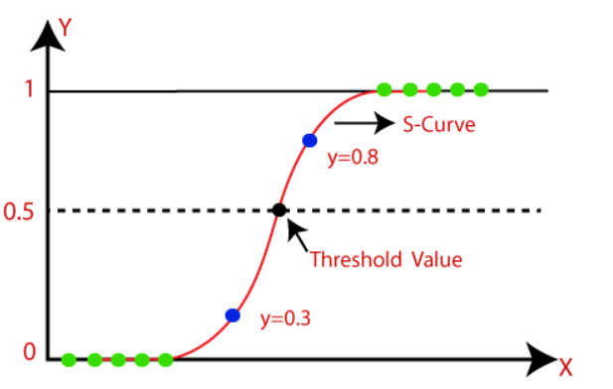

The equation for logistic regression is:

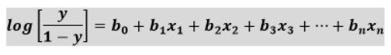

**DEEP LEARNING**

Deep learning is based on the branch of machine learning, which is a subset of artificial intelligence. Since neural networks imitate the human brain and so deep learning will do. In deep learning, nothing is programmed explicitly. Basically, it is a machine learning class that makes use of numerous nonlinear processing units so as to perform feature extraction as well as transformation. The output from each preceding layer is taken as input by each one of the successive layers.

Deep learning models are capable enough to focus on the accurate features themselves by requiring a little guidance from the programmer and are very helpful in solving out the problem of dimensionality. Deep learning algorithms are used, especially when we have a huge no of inputs and outputs.

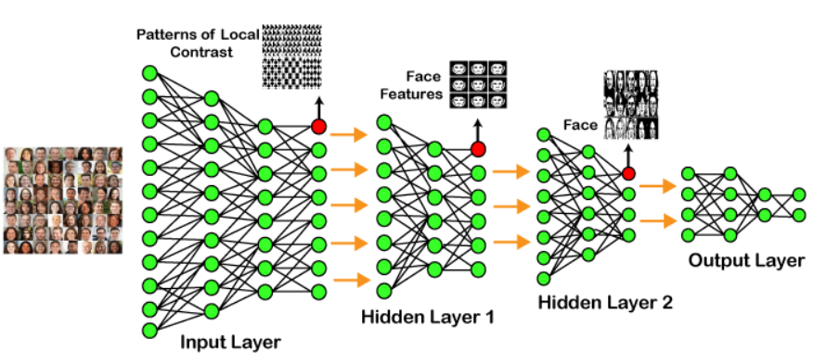

Types of Deep Learning Networks:

1. **Feed Forward Neural Network**

A feed-forward neural network is none other than an Artificial Neural Network, which ensures that the nodes do not form a cycle. In this kind of neural network, all the perceptrons are organized within layers, such that the input layer takes the input, and the output layer generates the output. Since the hidden layers do not link with the outside world, it is named as hidden layers. Each of the perceptrons contained in one single layer is associated with each node in the subsequent layer. It can be concluded that all of the nodes are fully connected. It does not contain any visible or invisible connection between the nodes in the same layer. There are no back-loops in the feed-forward network.

Applications:

Data Compression

Pattern Recognition

1. **Recurrent Neural Network**

Recurrent neural networks are yet another variation of feed-forward networks. Here each of the neurons present in the hidden layers receives an input with a specific delay in time. The Recurrent neural network mainly accesses the preceding info of existing iterations. For example, to guess the succeeding word in any sentence, one must have knowledge about the words that were previously used. It not only processes the inputs but also shares the length as well as weights crossways time.

Applications:

Machine Translation

Robot Control

1. **Convolutional Neural Network**

Convolutional Neural Networks are a special kind of neural network mainly used for image classification, clustering of images and object recognition. DNNs enable unsupervised construction of hierarchical image representations. To achieve the best accuracy, deep convolutional neural networks are preferred more than any other neural network.

Applications:

Identify Faces, Street Signs, Tumors.

Image Recognition.

1. **Restricted Boltzmann Machine**

RBMs are yet another variant of Boltzmann Machines. Here the neurons present in the input layer and the hidden layer encompasses symmetric connections amid them. However, there is no internal association within the respective layer. But in contrast to RBM, Boltzmann machines do encompass internal connections inside the hidden layer. These restrictions in BMs helps the model to train efficiently.

Applications:

Filtering.

Feature Learning

1. **Autoencoders**

An autoencoder neural network is another kind of unsupervised machine learning algorithm. Here the number of hidden cells is merely small than that of the input cells. But the number of input cells is equivalent to the number of output cells. An autoencoder network is trained to display the output similar to the fed input to force AEs to find common patterns and generalize the data. The autoencoders are mainly used for the smaller representation of the input. It helps in the reconstruction of the original data from compressed data. This algorithm is comparatively simple as it only necessitates the output identical to the input.

Encoder: Convert input data in lower dimensions.

Decoder: Reconstruct the compressed data.

Applications:

Classification.

Clustering.

**COMPARISON BETWEEN MACHINE LEARNING AND DEEP LEARNING:**

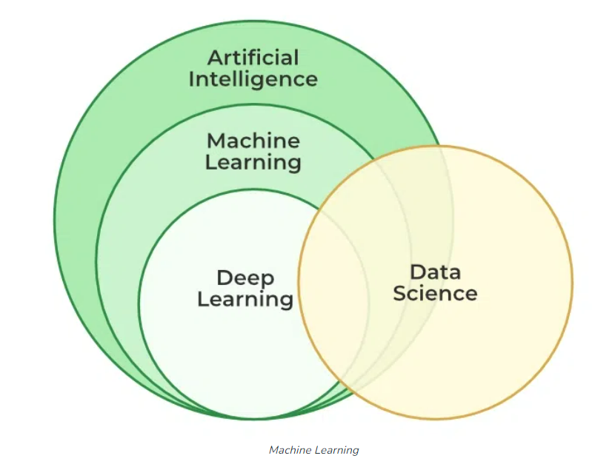

| **PARAMETER** | MACHINE LEARNING | DEEP LEARNING |
| --- | --- | --- |
| **Data Dependency** | Although machine learning depends on the huge amount of data, it can work with a smaller amount of data. | Deep Learning algorithms highly depend on a large amount of data, so we need to feed a large amount of data for good performance. |
| **Execution time** | Machine learning algorithm takes less time to train the model than deep learning, but it takes a long-time duration to test the model. | Deep Learning takes a long execution time to train the model, but less time to test the model. |
| **Hardware Dependencies** | Since machine learning models do not need much amount of data, so they can work on low-end machines. | The deep learning model needs a huge amount of data to work efficiently, so they need GPU's and hence the high-end machine. |
| **Feature Engineering** | Machine learning models need a step of feature extraction by the expert, and then it proceeds further. | Deep learning is the enhanced version of machine learning, so it does not need to develop the feature extractor for each problem; instead, it tries to learn high-level features from the data on its own. |
| **Problem-solving approach** | To solve a given problem, the traditional ML model breaks the problem in sub-parts, and after solving each part, produces the final result. | The problem-solving approach of a deep learning model is different from the traditional ML model, as it takes input for a given problem, and produce the end result. Hence it follows the end-to-end approach. |
| **Interpretation of result** | When we work with machine learning, we can interpret the result easily, it means why this result occur, what was the process. | When we work with the deep learning model, we may get a better result for a given problem than the machine learning model, but we cannot find why this particular outcome occurred, and the reasoning. |
| **Type of data** | Machine learning models mostly require data in a structured form. | Deep Learning models can work with structured and unstructured data both as they rely on the layers of the Artificial neural network. |
| **Suitable for** | Machine learning models are suitable for solving simple or bit-complex problems. | Deep learning models are suitable for solving complex problems. |

**CONCLUSION:**

In conclusion, we can say that deep learning is machine learning with more capabilities and a different working approach. And selecting any of them to solve a particular problem is depend on the amount of data and complexity of the problem.